

**Rotator Cuff Tear**

A partial or complete rotator cuff tear makes it difficult to raise and move your arm. You may have shoulder pain and arm weakness. Rotator cuff injuries are common, especially as you get older. Rest, pain relievers and physical therapy can help. Some people need surgery to reattach a torn rotator cuff.

**Overview**

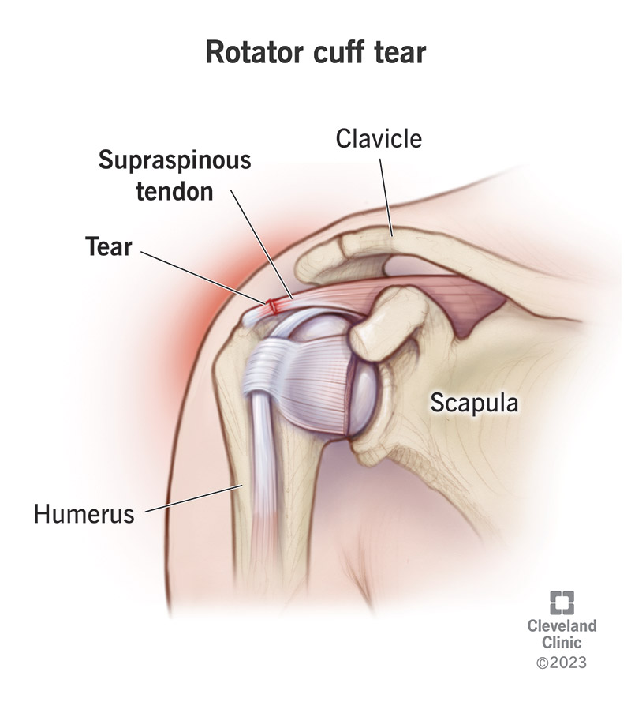A rotator cuff tear is an injury to your rotator cuff that can cause shoulder pain and the inability to use your arm.

**What is a rotator cuff tear?**

A rotator cuff tear is an injury to your [rotator cuff](https://my.clevelandclinic.org/health/articles/21504-rotator-cuff) that can cause shoulder pain and the inability to use your arm. Your rotator cuff is a group of muscles and tendons in your shoulder. They help you lift and move your arms away from your body. Your rotator cuff keeps the ball of your upper arm bone ([humerus](https://my.clevelandclinic.org/health/body/24612-humerus)) in the shoulder blade socket.

Your shoulder is a ball-and-socket joint that’s part of your [skeletal system](https://my.clevelandclinic.org/health/body/21048-skeletal-system). It’s like a golf ball sitting on a golf tee. Rotator cuff tears occur when tendons pull away from your arm bone. A tear may result from overuse or another injury.

**What are the types of rotator cuff tears?**

Types of torn rotator cuffs include:

* **Partial:** With an incomplete or partial tear, your [tendon](https://my.clevelandclinic.org/health/body/21738-tendon) still somewhat attaches to your arm bone.
* **Complete:** With a full-thickness or complete tear, your tendon separates completely from your bone. There’s a hole or rip in your tendon.

**How common are rotator cuff tears?**

More than 2 million Americans experience some type of rotator cuff problem every year. Rotator cuff tears affect people of all ages, but the problem is more common in adults. In fact, it’s so common that there are people who have rotator cuff tears and don’t even know they have one because they have no symptoms.

**Symptoms and Causes**

**What are the symptoms of a rotator cuff tear?**

Rotator cuff tear symptoms include:

* Difficulty, pain and weakness caused by raising, lowering or rotating your arm.
* Popping, clicking or crackling sounds or sensations when moving your arm in certain positions.
* Shoulder pain that worsens at night or when resting your arm.
* Shoulder weakness and struggling to lift items.

**What does a rotator cuff tear feel like?**

It depends. You may feel a dull ache deep within your shoulder, or it may feel like you’re being stabbed with a knife. Sudden tears from accidents or trauma cause immediate, intense shoulder pain and arm weakness. With degenerative tears, you may have mild pain that improves with over-the-counter (OTC) [pain relievers](https://my.clevelandclinic.org/health/treatments/12058-pain-relievers). Over time, the pain gets worse, and pain relievers don’t help. Not everyone has pain, but most people have some degree of arm and shoulder weakness.

**What causes rotator cuff tears?**

An accident, such as a fall, can cause a [broken collarbone](https://my.clevelandclinic.org/health/diseases/16874-broken-collarbone-clavicle-fracture) or [dislocated shoulder](https://my.clevelandclinic.org/health/diseases/17746-dislocated-shoulder) that tears your rotator cuff.

More commonly, rotator cuff tears occur over time as your tendon wears down with age and use (degenerative tear). People over age 40 are most at risk.

Causes of degenerative tears include:

* [**Bone spurs**](https://my.clevelandclinic.org/health/diseases/10395-bone-spurs-osteophytes)**:** Bony growths can form on the top of your shoulder bone. These bone spurs rub against your tendon when you lift your arm. This [shoulder impingement](https://my.clevelandclinic.org/health/diseases/7079-shoulder-impingement-syndrome) creates friction between your bone and tendon. Eventually, a partial or complete tear may occur.
* **Decreased blood flow:** Blood flow to your rotator cuff decreases as you get older. Your muscles and tendons need a healthy blood supply to repair themselves. If blood doesn’t nourish your tendons, they can tear.
* [**Overuse**](https://my.clevelandclinic.org/health/diseases/4706-overuse-syndrome-of-the-hands-and-arms)**:** Repetitive shoulder movements during sports or on the job can stress your muscles and tendons, causing a tear.

**What are risk factors for rotator cuff tears?**

Anyone can experience a rotator cuff tear. These factors may increase your risk:

* Biological family history of shoulder problems or rotator cuff injuries.
* Poor posture.
* [Smoking](https://my.clevelandclinic.org/health/articles/17488-smoking).
* Being age 40 or older.

Degenerative tears are more common among people who do the same repetitive shoulder movements, such as:

* Carpenters.
* Mechanics.
* Painters.
* Recreational and professional athletes who play baseball, softball and tennis or are part of a rowing crew.

**What are the complications of a rotator cuff tear?**

A rotator cuff tear can get worse without treatment. A complete tear can make it almost impossible to move your arm. Without treatment, you may have chronic shoulder pain and find it very difficult to use your injured arm.

**Diagnosis and Tests**

**How is a rotator cuff tear diagnosed?**

Your healthcare provider will perform a physical exam to check for shoulder tenderness, range of motion and arm strength.

To confirm a diagnosis, you may get:

* An [X-ray](https://my.clevelandclinic.org/health/diagnostics/22531-shoulder-x-ray) to check for [arthritis](https://my.clevelandclinic.org/health/diseases/22491-shoulder-arthritis) or bone spurs.
* An [MRI](https://my.clevelandclinic.org/health/diagnostics/4876-magnetic-resonance-imaging-mri) (magnetic resonance imaging) or [ultrasound](https://my.clevelandclinic.org/health/diagnostics/4995-ultrasound) to look for tendon tears.

**Management and Treatment**

**What is the treatment for a rotator cuff tear?**

Rotator cuff tear treatment may include nonsurgical and surgical options.

**Nonsurgical options**

Rotator cuff tears don’t heal on their own without surgery, but many people can improve functionally and decrease pain with nonsurgical treatment by strengthening their shoulder muscles. Just because you have a tear doesn’t necessarily mean you need surgery, as many people have rotator cuff tears and don’t even know it. About 8 out of 10 people with partial tears get better with nonsurgical treatments. It can take up to a year for the condition to improve.

Nonsurgical treatments include:

* **An arm sling and rest** to give your shoulder time to heal. You may need to modify activities and stop certain work or sports for a period of time.
* [**Nonsteroidal anti-inflammatory drugs (NSAIDs)**](https://my.clevelandclinic.org/health/drugs/11086-non-steroidal-anti-inflammatory-medicines-nsaids) to minimize pain and swelling.
* **Physical therapy** to learn strengthening and stretching exercises.
* [**Steroid injections**](https://my.clevelandclinic.org/health/treatments/4934-steroid-injections) to ease pain and swelling.

**Surgical options**

Your healthcare provider may recommend surgery if you have a complete tear or nonsurgical treatments don’t help a complete or partial tear. You may also have surgery if your job or athletic interests affect your shoulder.

Most rotator cuff surgeries take place [arthroscopically](https://my.clevelandclinic.org/health/treatments/21801-arthroscopy) through small cuts (incisions). Occasionally, the surgeon will use an open approach when needed. The surgery is an outpatient procedure. You go home the same day, but the overall recovery after this surgery is very substantial and can take up to a year or more.

During surgery, your healthcare provider:

1. Inserts an arthroscope (small camera) through a small incision in your shoulder.
2. Refers to images from the arthroscope to perform the procedure.
3. Inserts tiny instruments into small incisions in your shoulder to remove bone spurs and reattach your tendon to your upper arm bone.

For a partial tear, your healthcare provider may only need to trim fraying pieces of a partially torn tendon. This debridement procedure keeps your shoulder ball and socket from catching on your tendon and tearing it more.

Some tears aren’t repairable due to their size and/or the age of the tear. For these types of tears, you may need [reverse shoulder replacement](https://my.clevelandclinic.org/health/procedures/reverse-shoulder-replacement), tendon transfer or a debridement of scar tissue without repair.

**What is the rotator cuff tear recovery time?**

After surgery, you need to wear a sling to immobilize your arm for four to six weeks. You can then start physical therapy. Most people regain shoulder function and strength within four to six months after surgery, but full recovery may take up to 12 to 18 months.

**Prevention**

**How can I prevent a symptomatic rotator cuff tear?**

To prevent a symptomatic rotator cuff tear, it’s important to keep your muscles and tendons flexible. Your healthcare provider can teach you [stretching](https://health.clevelandclinic.org/tag/shoulder-stretches/) and strengthening exercises to do at home.

**Outlook / Prognosis**

**What is the prognosis (outlook) for people who have a rotator cuff tear?**

Most people see improvements with nonsurgical treatments. Recovery takes time because your body needs time to heal. Most people who have surgery to repair a torn rotator cuff regain function.

It’s possible to tear the same tendon again, especially if the first tear was bigger than 1 inch. A re-tear that causes severe pain or loss of movement may require surgery.

**Living With**

**When should I call my healthcare provider?**

You should call your healthcare provider if you experience:

* Chronic shoulder and arm pain.
* Pain that worsens at night or interferes with sleep.
* Redness, swelling or tenderness in your shoulder joint area.
* Shoulder or arm weakness.

**What questions should I ask my healthcare provider?**

You may want to ask your healthcare provider:

* What caused the rotator cuff tear?
* What’s the best treatment for me?
* What can I do to lower the risk of getting another rotator cuff tear?
* Should I look out for signs of complications?
* What are signs of complications?

**A note from Cleveland Clinic**

If you work a very physical job or you’re an athlete, a rotator cuff injury will likely bench you, but it doesn’t have to be the end of your career. Talk to your healthcare provider about the best treatment options, whether nonsurgical or surgical. Your shoulder may be weak and painful for a while, but it’ll eventually heal.

